|  |  |
| --- | --- |
| **TEAM ID** | **PNT2022TMID01164** |

**CREATE IBM WATSON IoT PLATFORM AND DEVICE**

**AIM:**

To create the IBM Watson IoT platform and device

**STEPS:**

1. Firstly create an IBM cloud account with IBM id and password

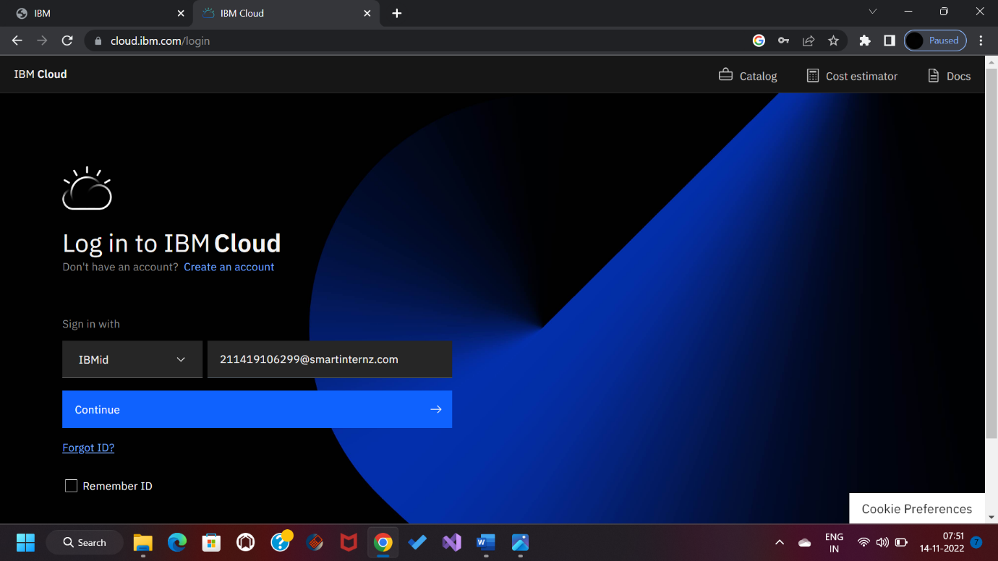

1. Home page of IBM cloud



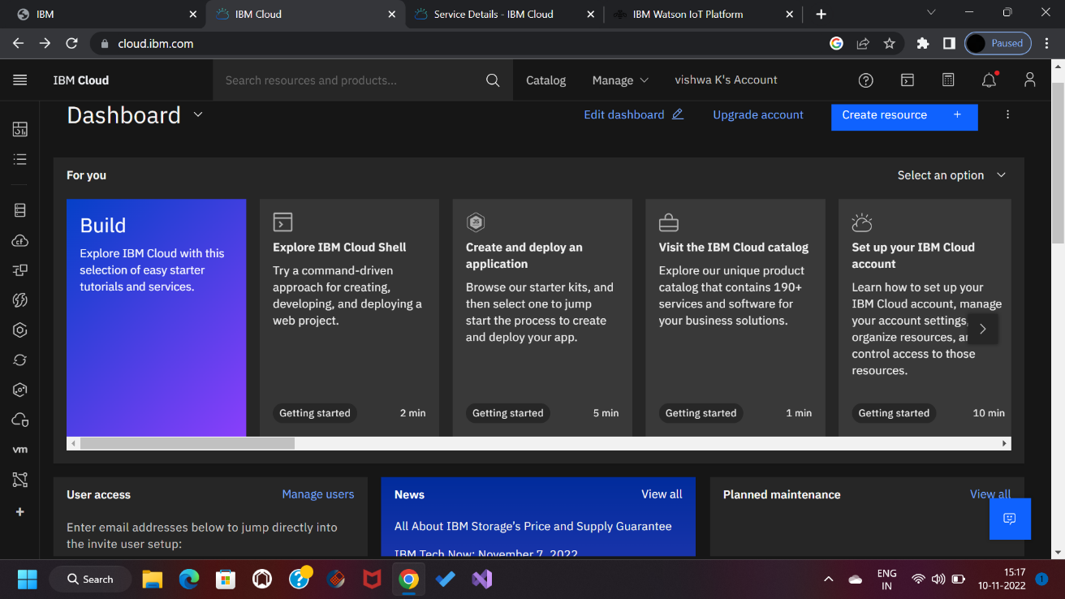

1. Click on resource list

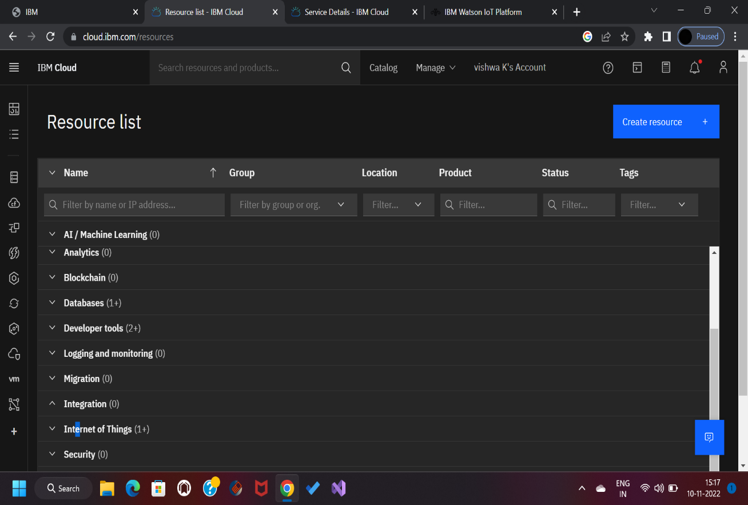

1. 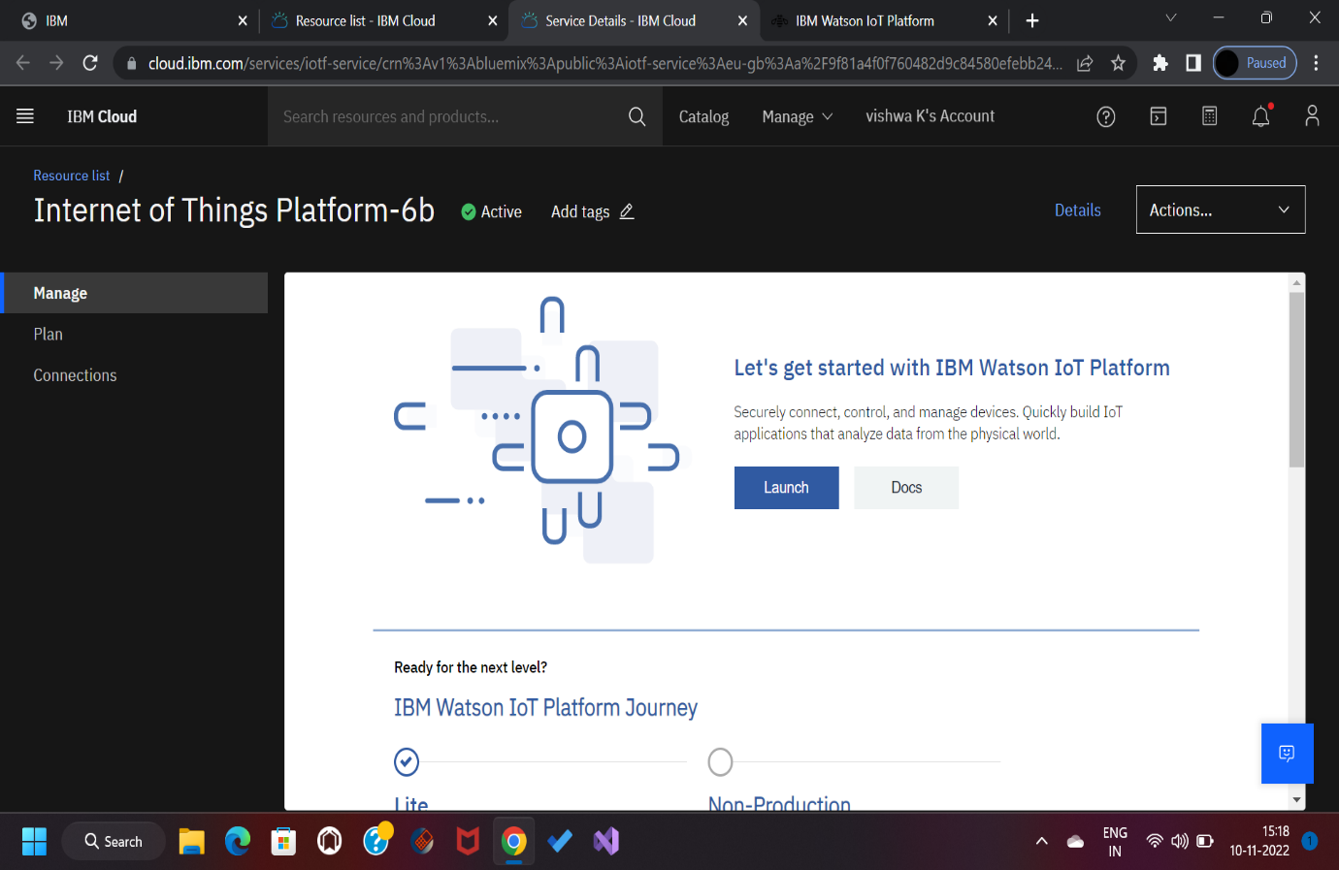Click on IoT in the category mentioned
2. Click on the launch button in the manage tab, it will open to this

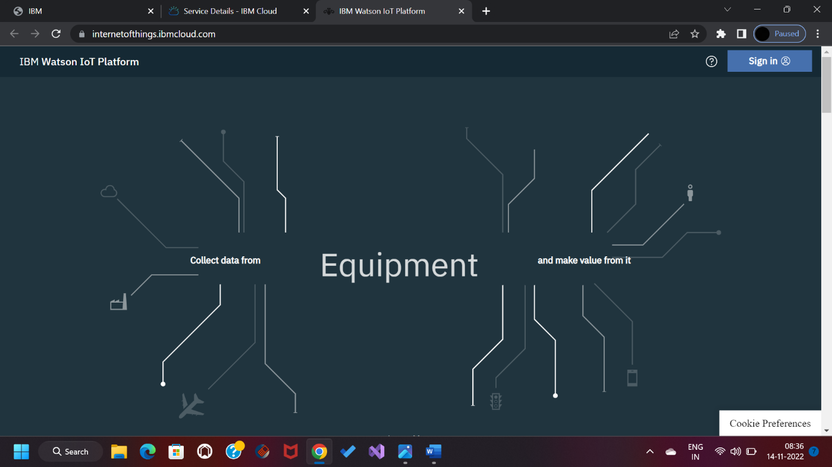

1. 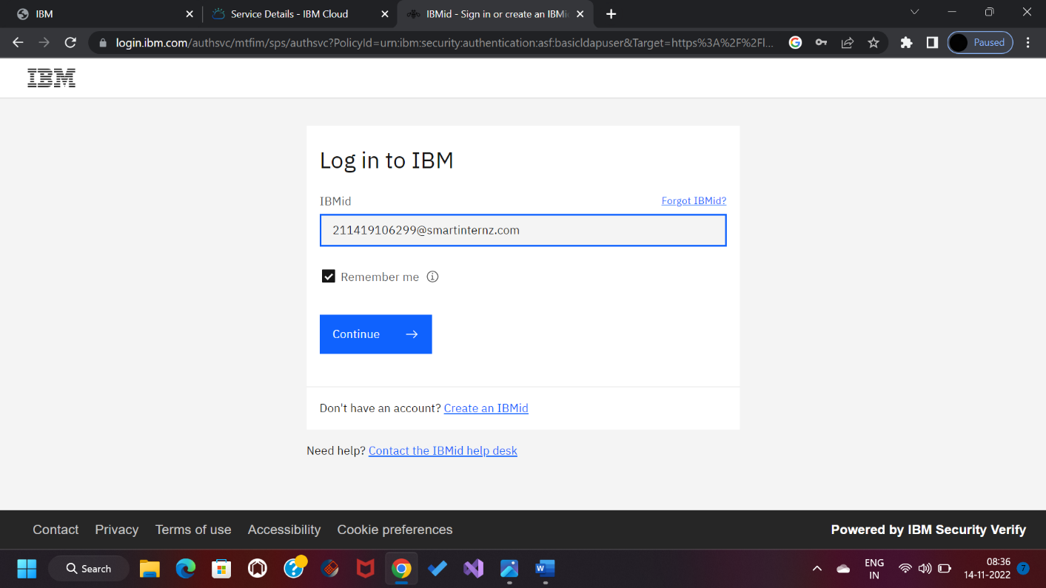 Enter the details to sign in to the Watson Cloud to create a device
2. Click on the device tab and click on the add device button, then give the device type and device id and click next

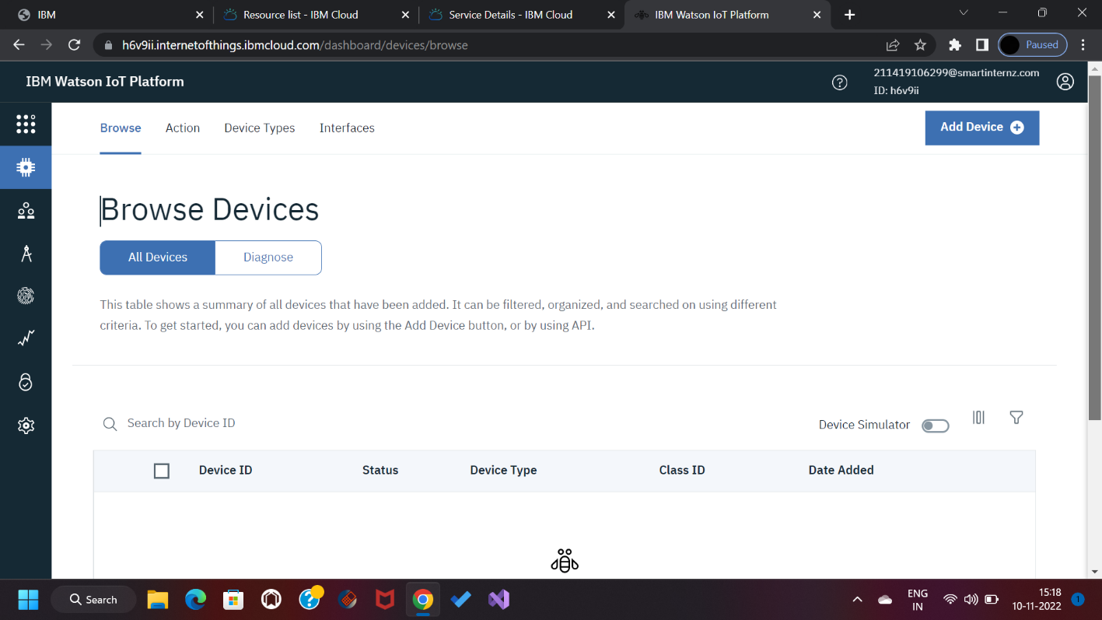

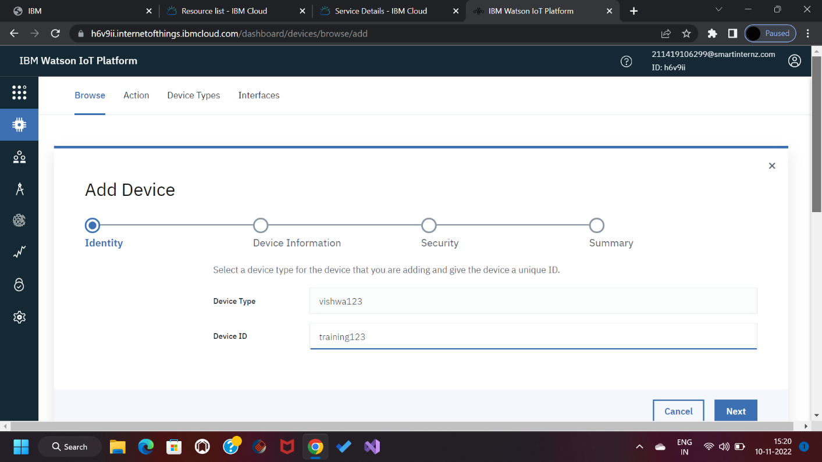

1. This page is to enter extra details and of the hardware and clicking on next it goes to the summary of the device then click finish

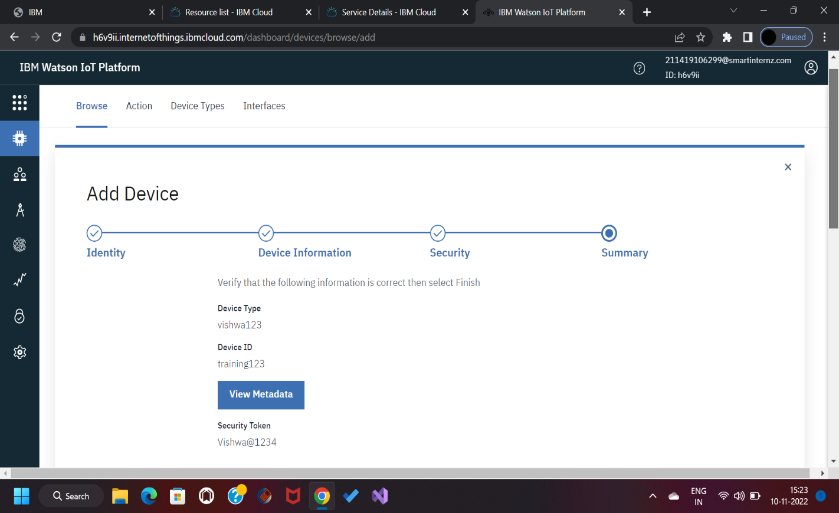

1. Save the details of the device as the authentication tokens are non-recoverable and if misplaced then we have to create a new one

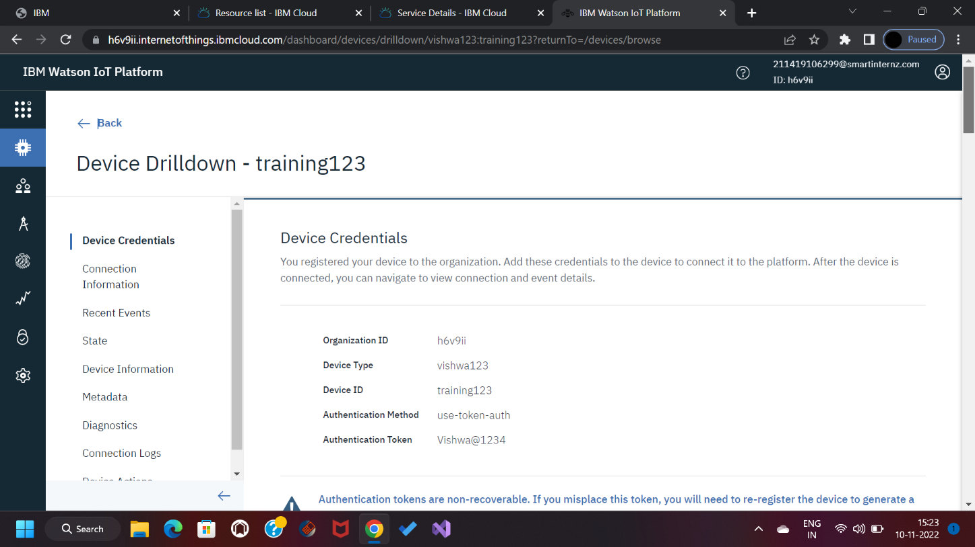

1. 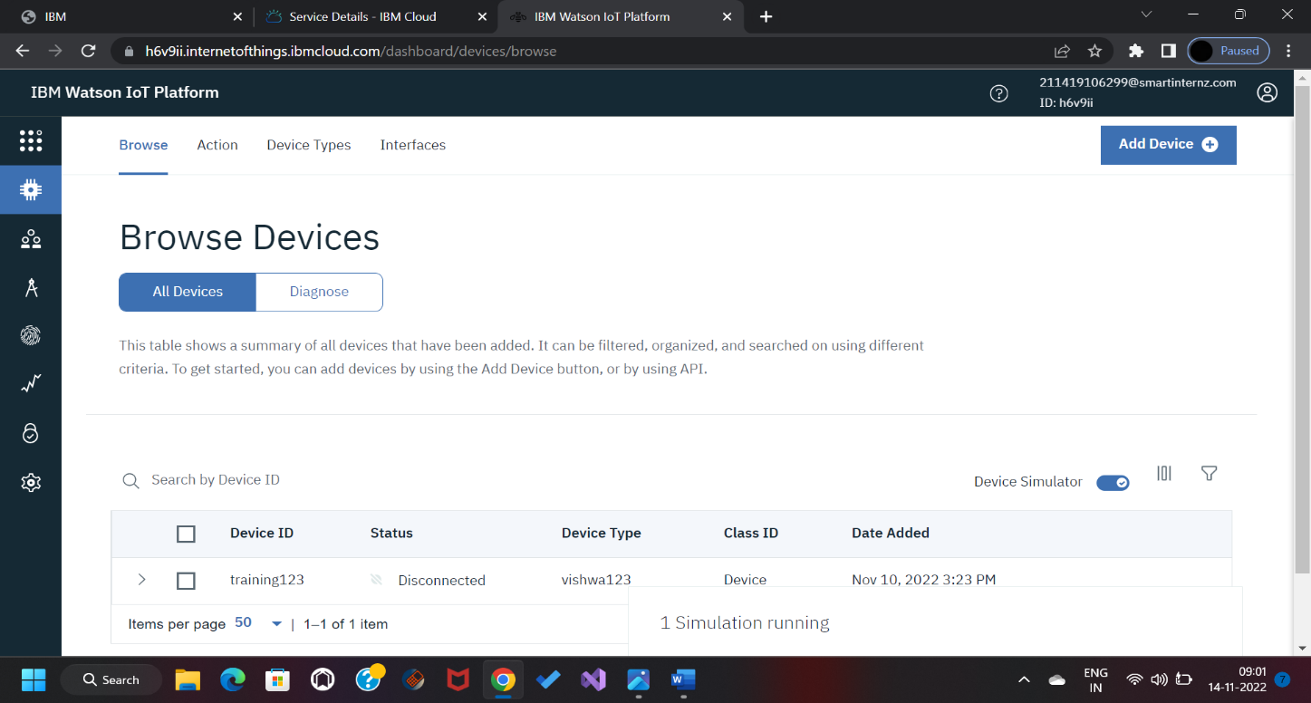 Clicking on the device tab we can see the added device. Clicking on it will display the other details

In a similar way, we can create n number of devices with a 50 a per page limit as per the requirement of our project

1. 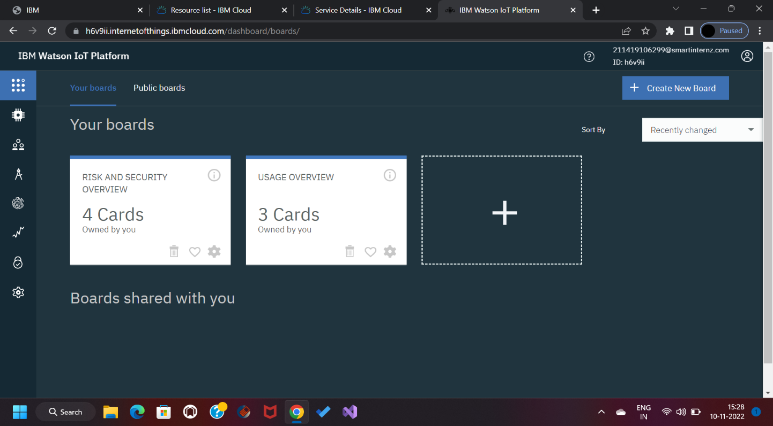The Boards will display card for project

RESULT:

An IBM Watson cloud for IoT and a device is created